When given the possibility to finally create a game on my own without constraints, the hardest part is to start designing it. There are so many genres and styles to pick from that the possibilities seem endless. With *Unresolved*, I wanted to try my shot at an escape the room type of game that differs from the usual style, since I found it kind of boring in itself. That’s why I decided to go for a 3rd person point of view that would highly focus on a metaphor. To a certain point, I eventually decided to take that metaphor as the main point of my game and having all my elements revolve around it. I chose to talk about the five stages of grief and have my escape the room being around this idea of having five rooms representing each stage. I then expended on having my own take on an escape the room game by changing some of the core elements of this genre. Not only mine would be third person, but I removed the inventory system where now you could only hold one item at the time. I also played with the idea that you can’t go back into the previous rooms, so you had to choose wisely which item you carried with you to the next room.

With that whole idea in mind, I started developing and designing the game. To begin, I wanted to find the style and core mechanic of the game. I got inspired by The Legend of Zelda: Link’s Awakening (the remake, 2019) room design[1] when you’re inside, where you see the walls around you and you’re surrounded in a dark area. I thought this would work well for the style of my game since I went for a cartoony look and it was a 3rd point of view experience. I then worked on finding my core mechanic of moving around. Using the navigation system in Unity, I developed a script to control the character’s position by clicking on the floor. I also added the camera control with the mouse position and the scroll wheel to zoom in and out. After testing this mechanic in a test scene, I implemented these elements in what would be the first room in order to have a first prototype.[2] As recommended, I then focused on designing some puzzles.

By then, I had already sat down and designed the main elements in my game. I first figured out an outline for the mechanics and how to implement them. I then thought about my metaphor. Since I wanted my game to revolve a lot around it, I want to find a way to represent that metaphor as much as possible. That’s why I designed the puzzles[3], the room themes, the story and the gameplay to express their own stage of grief in each room. Firstly, the puzzles. I played a lot with this concept since I made the core of it simple, but the uses behind it more confusing. They’re all based on finding items and using them on other object to open, unlock and interact in a way with them. You do that until you find the right combination to open the door and move to the next one. The thing I played with is how, although this mechanic stays throughout the whole game, it’s used differently in each room. In the first one, I make it seem easy for all you do is use object to interact with other objects. By the second room, the useful items become harder to find and their uses become more mysterious. As an example, in the first room I have the player find a key card and use it on the computer machine to start a minigame. Completing it would lead to the doors opening. In the second room, I also have the same concept, but the power is off. If you manage to find the hidden crowbar, open the truck, use the generator to turn on the power and still have a key card with you, using it on the computer allows you to play the minigame again. Only this time, it is impossible to beat. The real way to move on is by a switch that appeared elsewhere when you turn on the power, but because I introduce this minigame mechanic in the first room, the player still believes that the minigame is the way to open the door so he might get angry by trying again and again to beat this impossible game. I got this idea by surveying people and asking them what made them angry in a video game. Most said dying/failing a lot in a part they feel they should be able to beat. I took that idea and put it into my game with this minigame. Since I wanted to express anger from that room as much as possible, this was a good way to provoke the player. From there I developed the rest of the rooms[4] and their themes. As stated, I wanted to bring the 5 stages of grief metaphor to the max by not only showing it, but by trying to have the player feel these emotions.

Lets go room by room[5]. In the first one, the goal was to represent denial. The way I chose to express that was giving the player the idea that this game was going to be easy. Introduce simple mechanics and one on one interaction with the objects. A straightforward logical puzzle that has its challenges, but nothing to make you worry about. I also added some visual elements, like the exit sign on the wall on the right, to enhance that belief. The second room is anger. This is where the fun begins, for my goal was to make the player angry. My methods? Fight the mechanics, principles and idea I had just built in the previous room. Making it so that we couldn’t go back in previous rooms was also a big part of this method. Since you can only carry one item, I wanted the player to think he didn’t bring the right item with him(like a hammer to destroy the boxes, thus finding new items), then making him believe he made a mistake and now he’s stuck. Truth is for every room, you have the necessary items in that room to complete the puzzle. The third room is all about bargaining. The core idea behind this room is making the player feel there’s nothing he can do because he didn’t bring the right item or didn’t choose the right door in the second room. Both doors lead to the same room, but the player doesn’t know that, so he might believe that he should’ve gone to the other one. The only way to solve this room is wait. Truth is there’s nothing you can do, no matter what item you bring with you. Only time heals. After a while in that room, a switch appears (as if you just found it), making you able to complete the puzzle. The fourth room represent depression, and would be a maze. The same mechanics and puzzle, but in a maze. The labyrinth comes to represent the idea of being lost, often related to the stage of depression. This room is simply a lot of back and forth inside the maze, representing once again this cycle of loneliness and stranding during depression. Finally the last scene doesn’t offer much of a puzzle, since it’s all about acceptance. You would be placed at the bottom of the laboratory, where you would realize the truth. This one is mostly related to the story, for it would give insight on the resolution. Giving you access to an elevator, you would be given the choice of coming down and accepting your fate and your place in the story where you can’t escape, or going back up and start the whole game over again, back to denial.

Regarding the story this time[6], we see that the metaphor also holds its place. You wake up in room one with no memory of who and where you are. All you know is that you want to get out of here. Following the signs, you deny that escaping will be much of an issue. As you move forward to room two, you start to unveil what kind of place you’re at. Some memories start to come back and you realize you might be more familiar to this place that what you would like to believe. Still, you can’t help but feel anger and disgust about what happened here, for you see weird machines and experiments all around you. As you get to the third room, you start to recognize faces on pictures. Still unsure of what is going on, you start to realize your presence in this place. Still, you try to bargain and find other alternatives to separate you from this place, for you don’t want to be associated with it. By the time you get to the end of the fourth room, you realize you somehow remember the way around this maze. You definitely have been here before, and more than once. As you uncover what happened to the place, you are hit with sadness when you realize there’s been a chemical leak in the labs and everyone there died. The final room is when you remember that you worked here. You were the project manager, you did all this. You are also dead. In the elevator, you are given the choice of accepting your fate and dying or denying everything again and restarting this endless cycle of grief. As we can see, each piece of the story represent its own stage of grief.

Now that I had the puzzles laid down, the core moving mechanics working, the story developed and the gameplay mostly defined, it was time to implement all of it in the game. Presenting my project to people, they gave me feedback on small insights like visual updates or small adjustments, but no one denounced a major problem with the core of the game, so I moved on with it. I already had the base of the first room down, so it was only a matter of finishing it and trying it. After adding all the models, animations and scripts, I playtested the game a bit. The main aspect that came back what that is was hard to know what you could interact with. This is when I added two elements: when your mouse hover an interactable object, you get a small description of the object, and these interactable objects have a color, where the rest of the room is in black and white. I decided to use letters on the ground to tell the story, since it not only allowed no other character or narrator to be present, but also made an interesting hint to the metaphor since these letters could have been left there by the main character himself, as he was going through this cycle over and over again. I then developed the minigame present in room one and two. Using sound as feedback, I believe the goal becomes straightforward after a while and requires no instructions. Having all the mechanics working and ready, making room two and three was easier. All I had to do was tweak some script to have them follow the changes I previously explained in the puzzles. I believe the core of this game is not with it’s mechanics, but more with its play on the player and this whole idea of feedback/interaction with him. This is why the design part was harder and more crucial that the building part.

I then added all the sounds to make sure the experience you share the intent I wanted. After playtesting, I noticed it was indeed working as I wanted. The soundtrack plays a big role on the ambiance I wanted to create, which was one of mysteries and ominous. I had the help of my great friend Yanick Sernoskie who studies sound making for video games to create that soundtrack for me. With the game having a solid build so far, the next time I presented the project went well (update 3)[7]. One of the main elements that came out of this discussion was an idea proposed where I should have the accent color change in each room to also represent the stage of grief present in the room. I immediately implemented that into the game, for I thought it was a great idea to enhance not only the visual, but also the metaphor itself.

To this point, room one, two and three are done and I believe that if I implement room four and five in the same way, the game could be mostly done. Of course, I would like to have before that a bigger playtesting in order to solidify the base of the game before continuing it. If the intent goes through as wanted, I would then complete the final rooms and add this aspect of choosing to accept your fate in the elevator or denying and starting over again. If these elements are added correctly, I believe the game would be mostly done and could work well for its purpose.

**Index**

1. The Legend of Zelda: Link’s Awakening (2019)

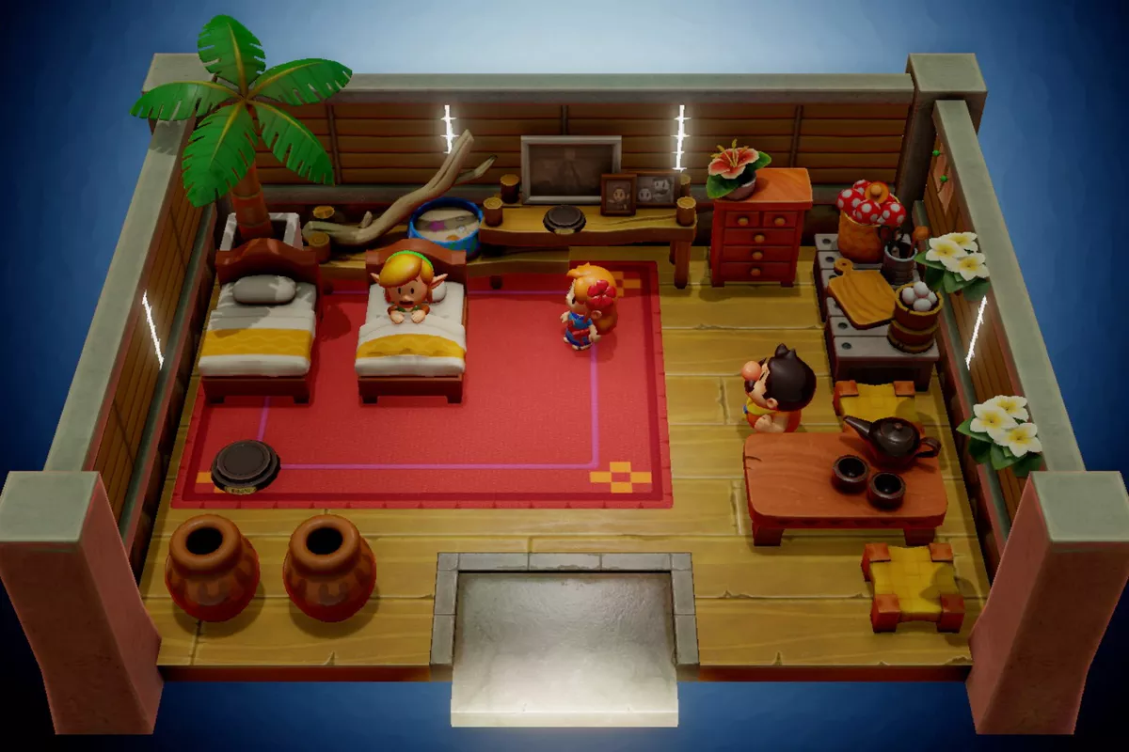

2. Class update 2

<https://docs.google.com/presentation/d/17pSAM1y2J6EocLV-eYjV2rbhML7--Ogt-1bhSwLNlPM/edit#slide=id.p>

3. The Puzzles

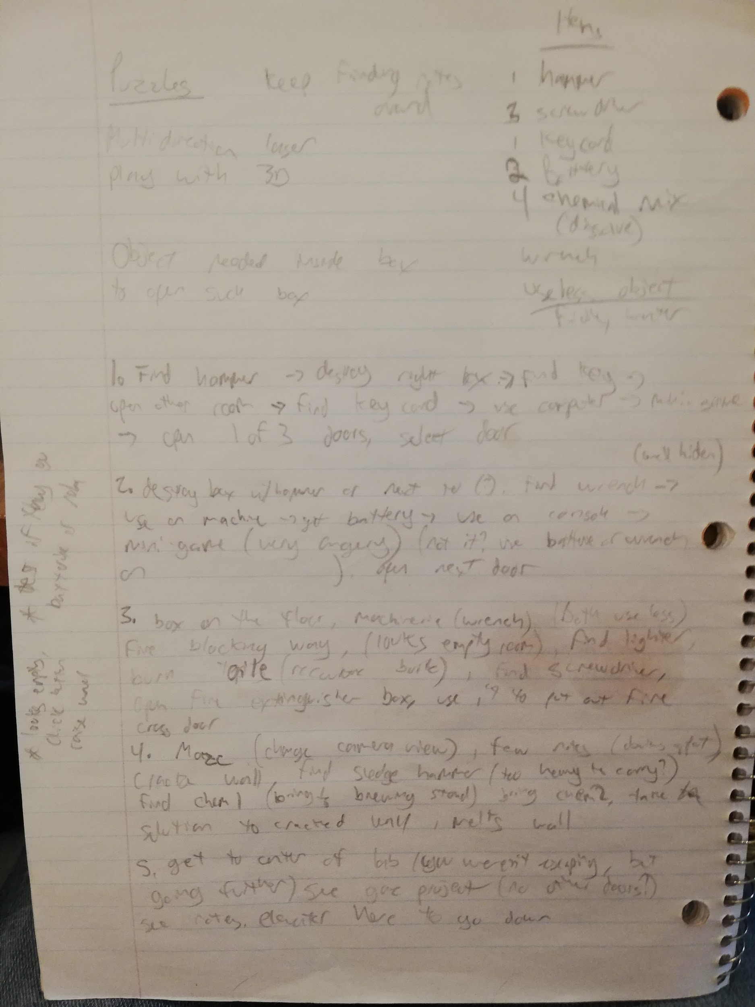

4. The room designs

Room 1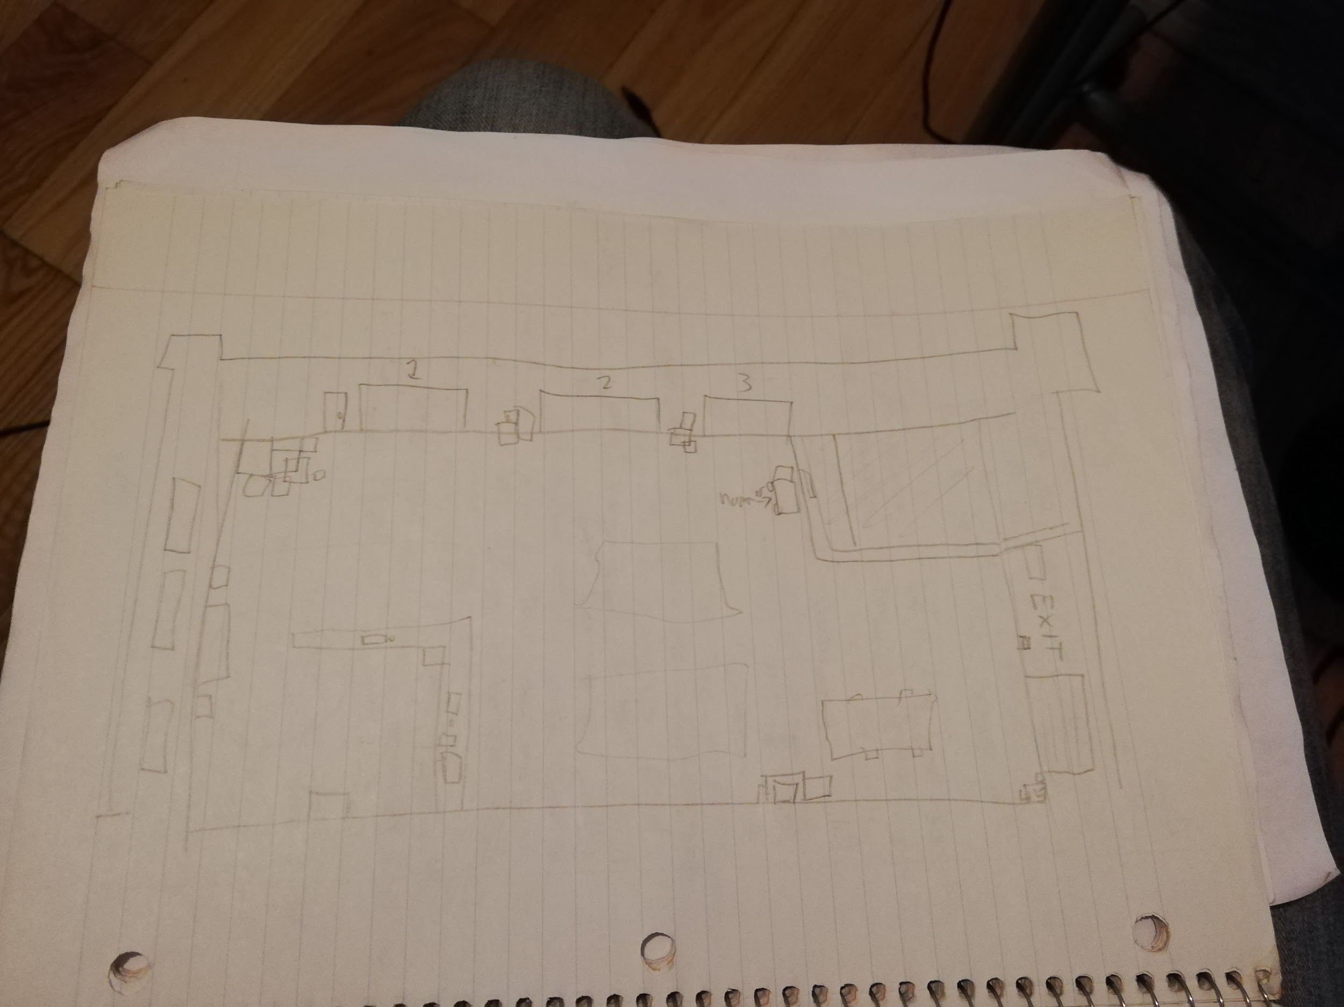

Room 2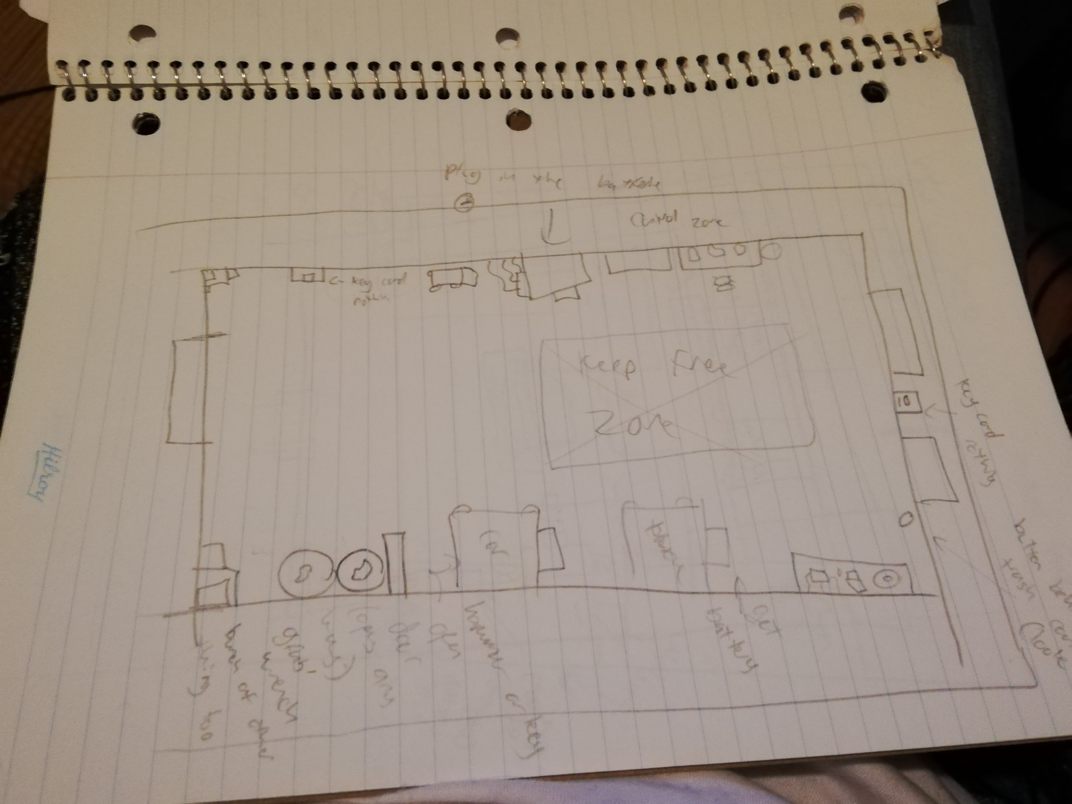

Room 3

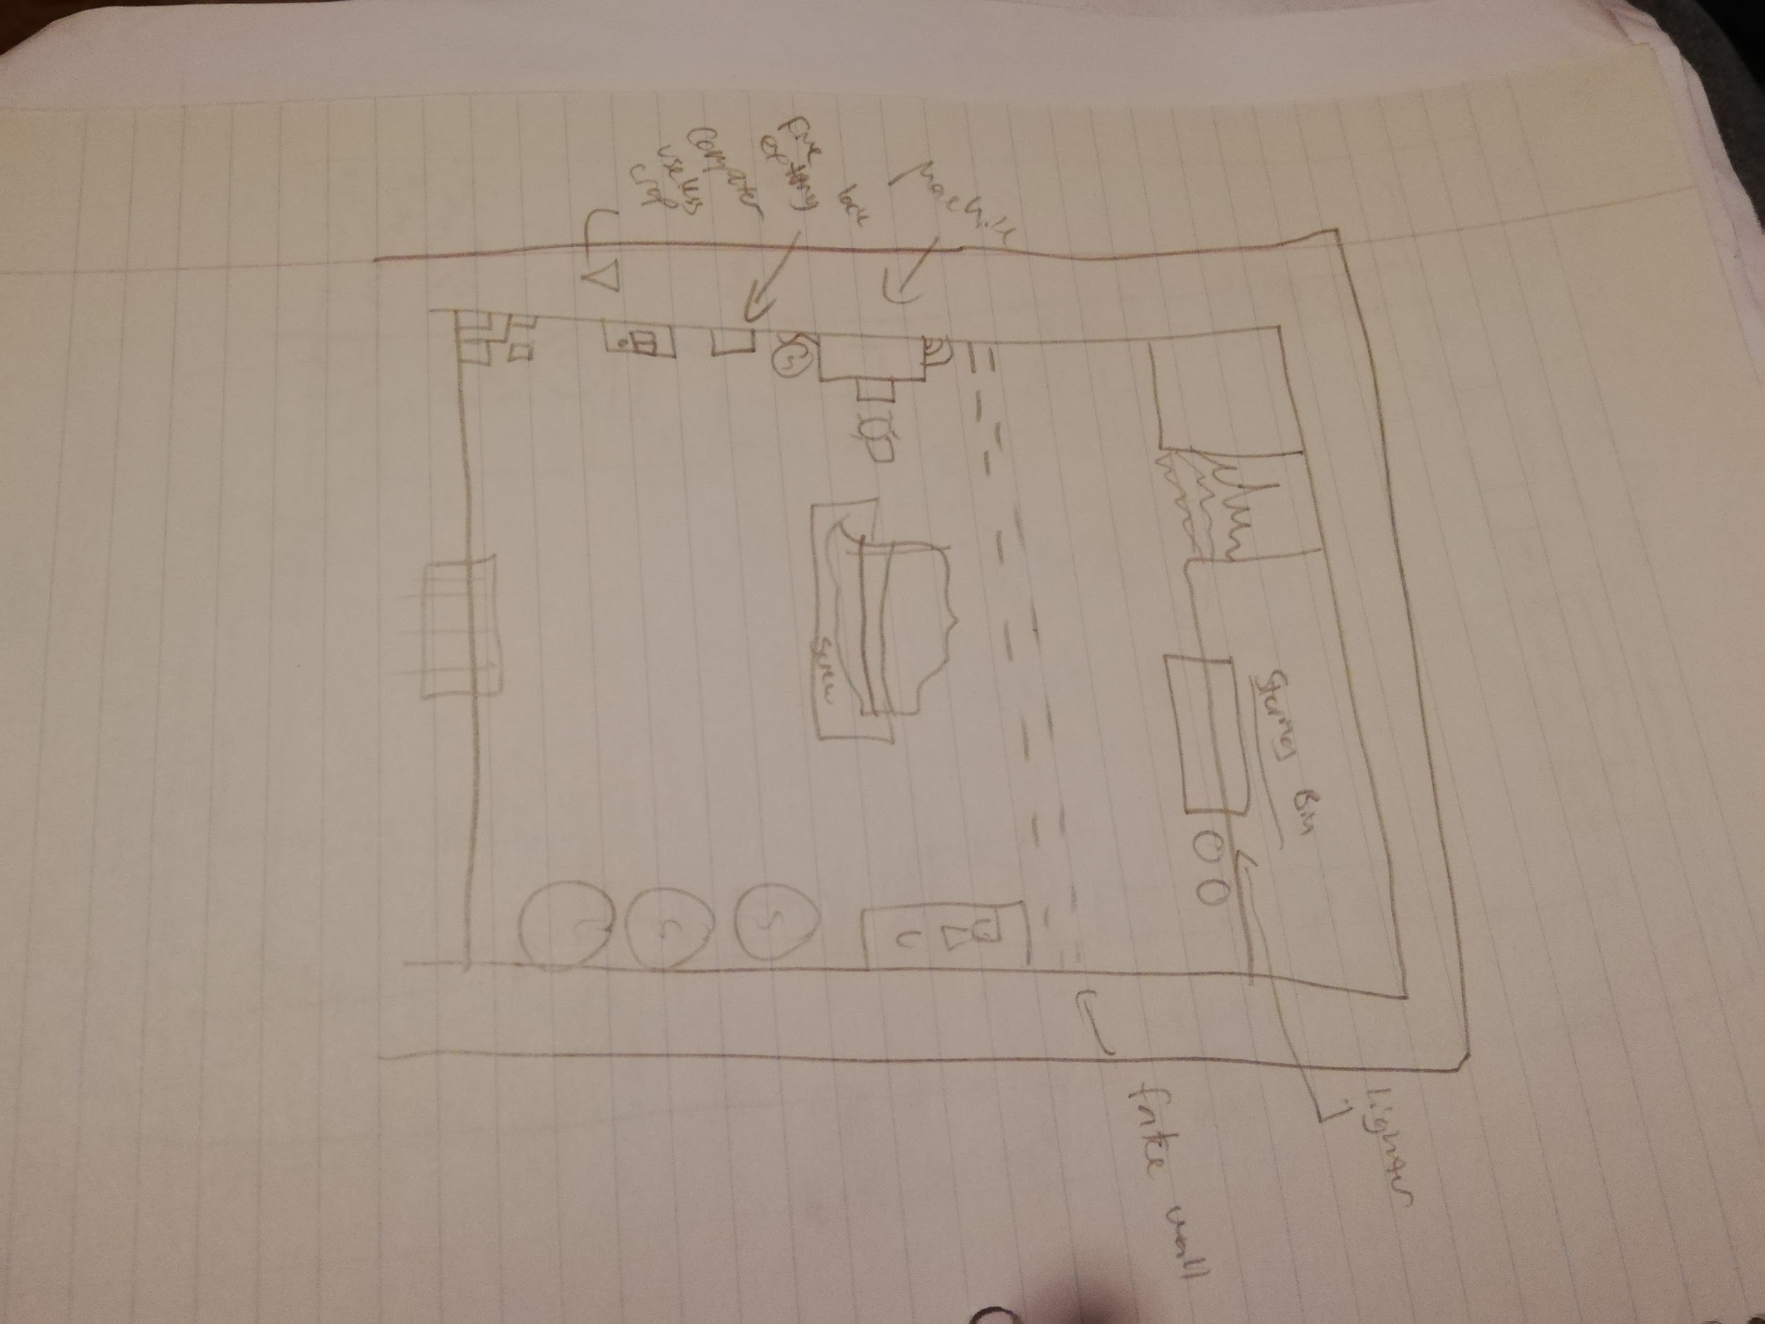

Room 4

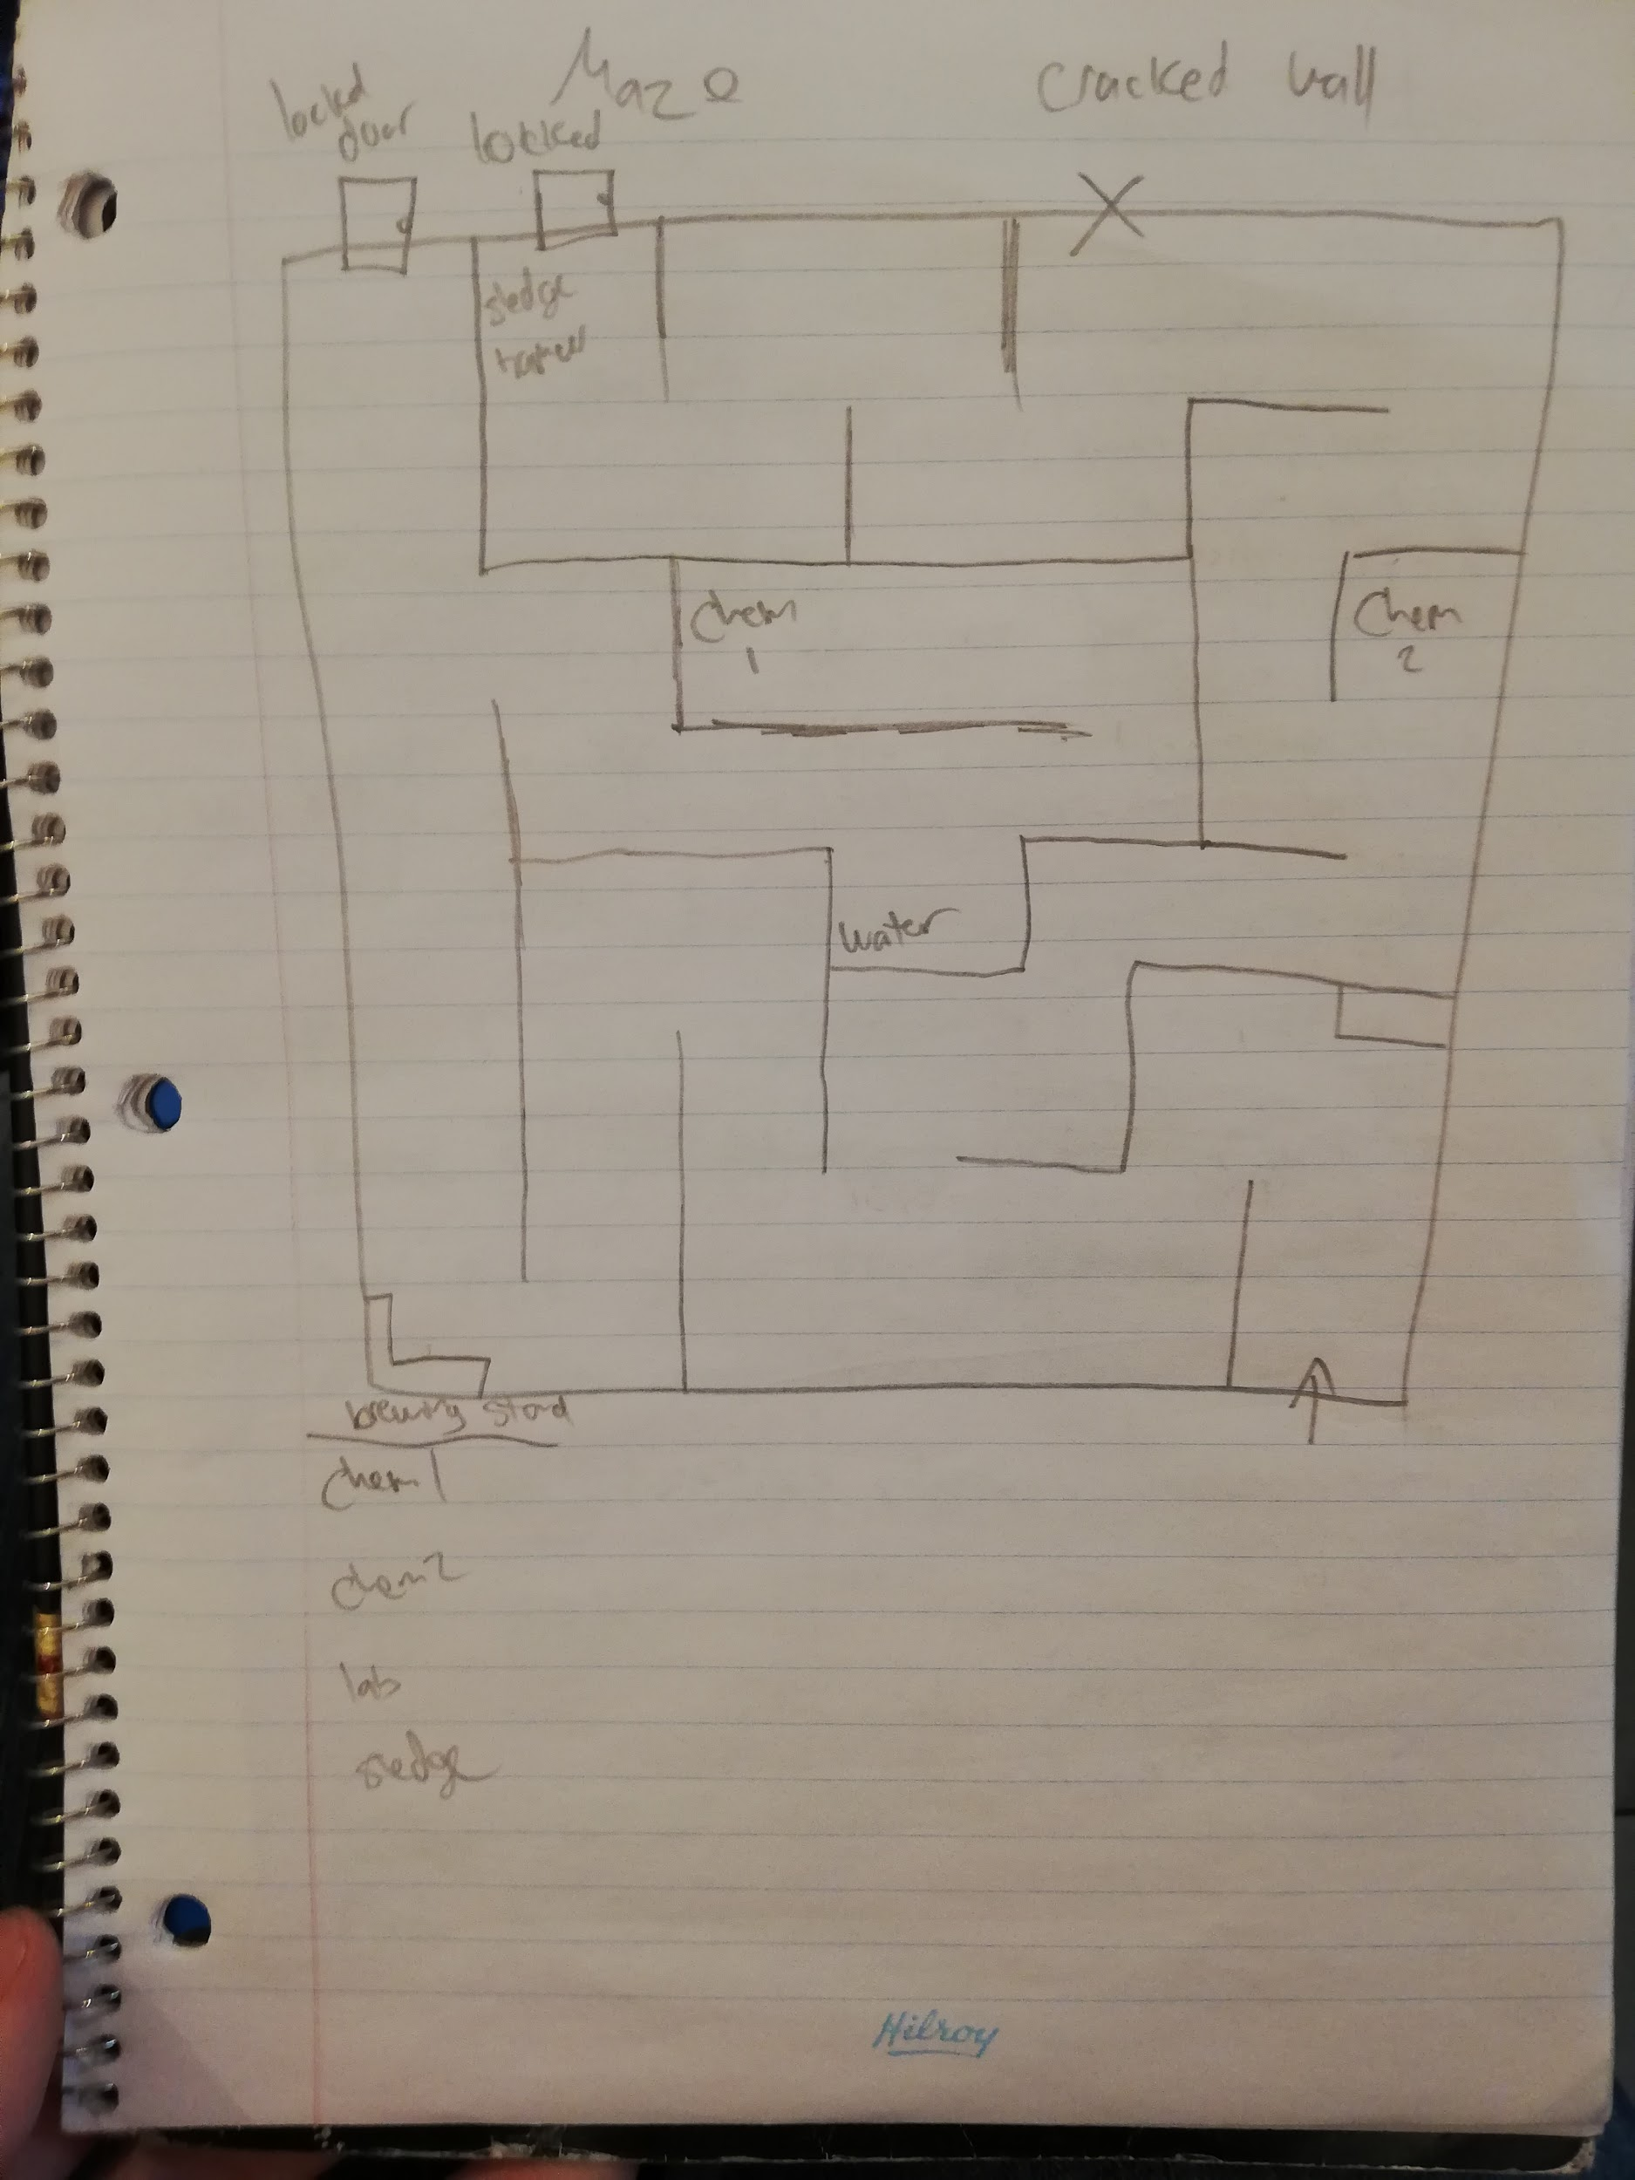

5. The room themes and objectives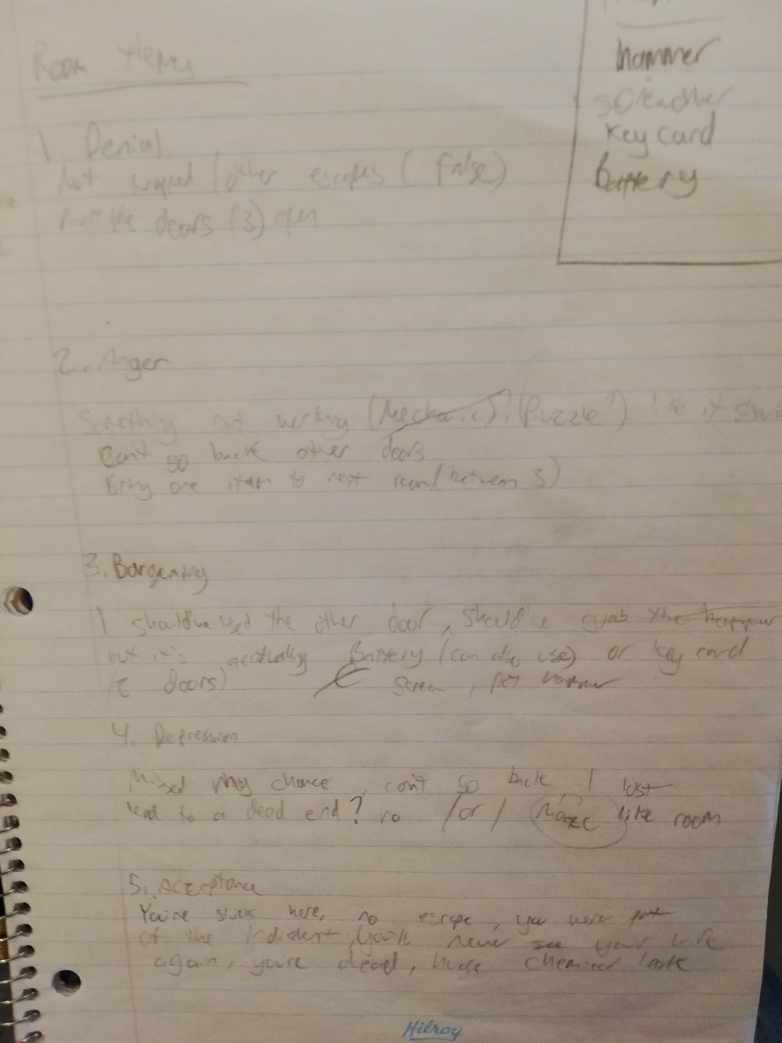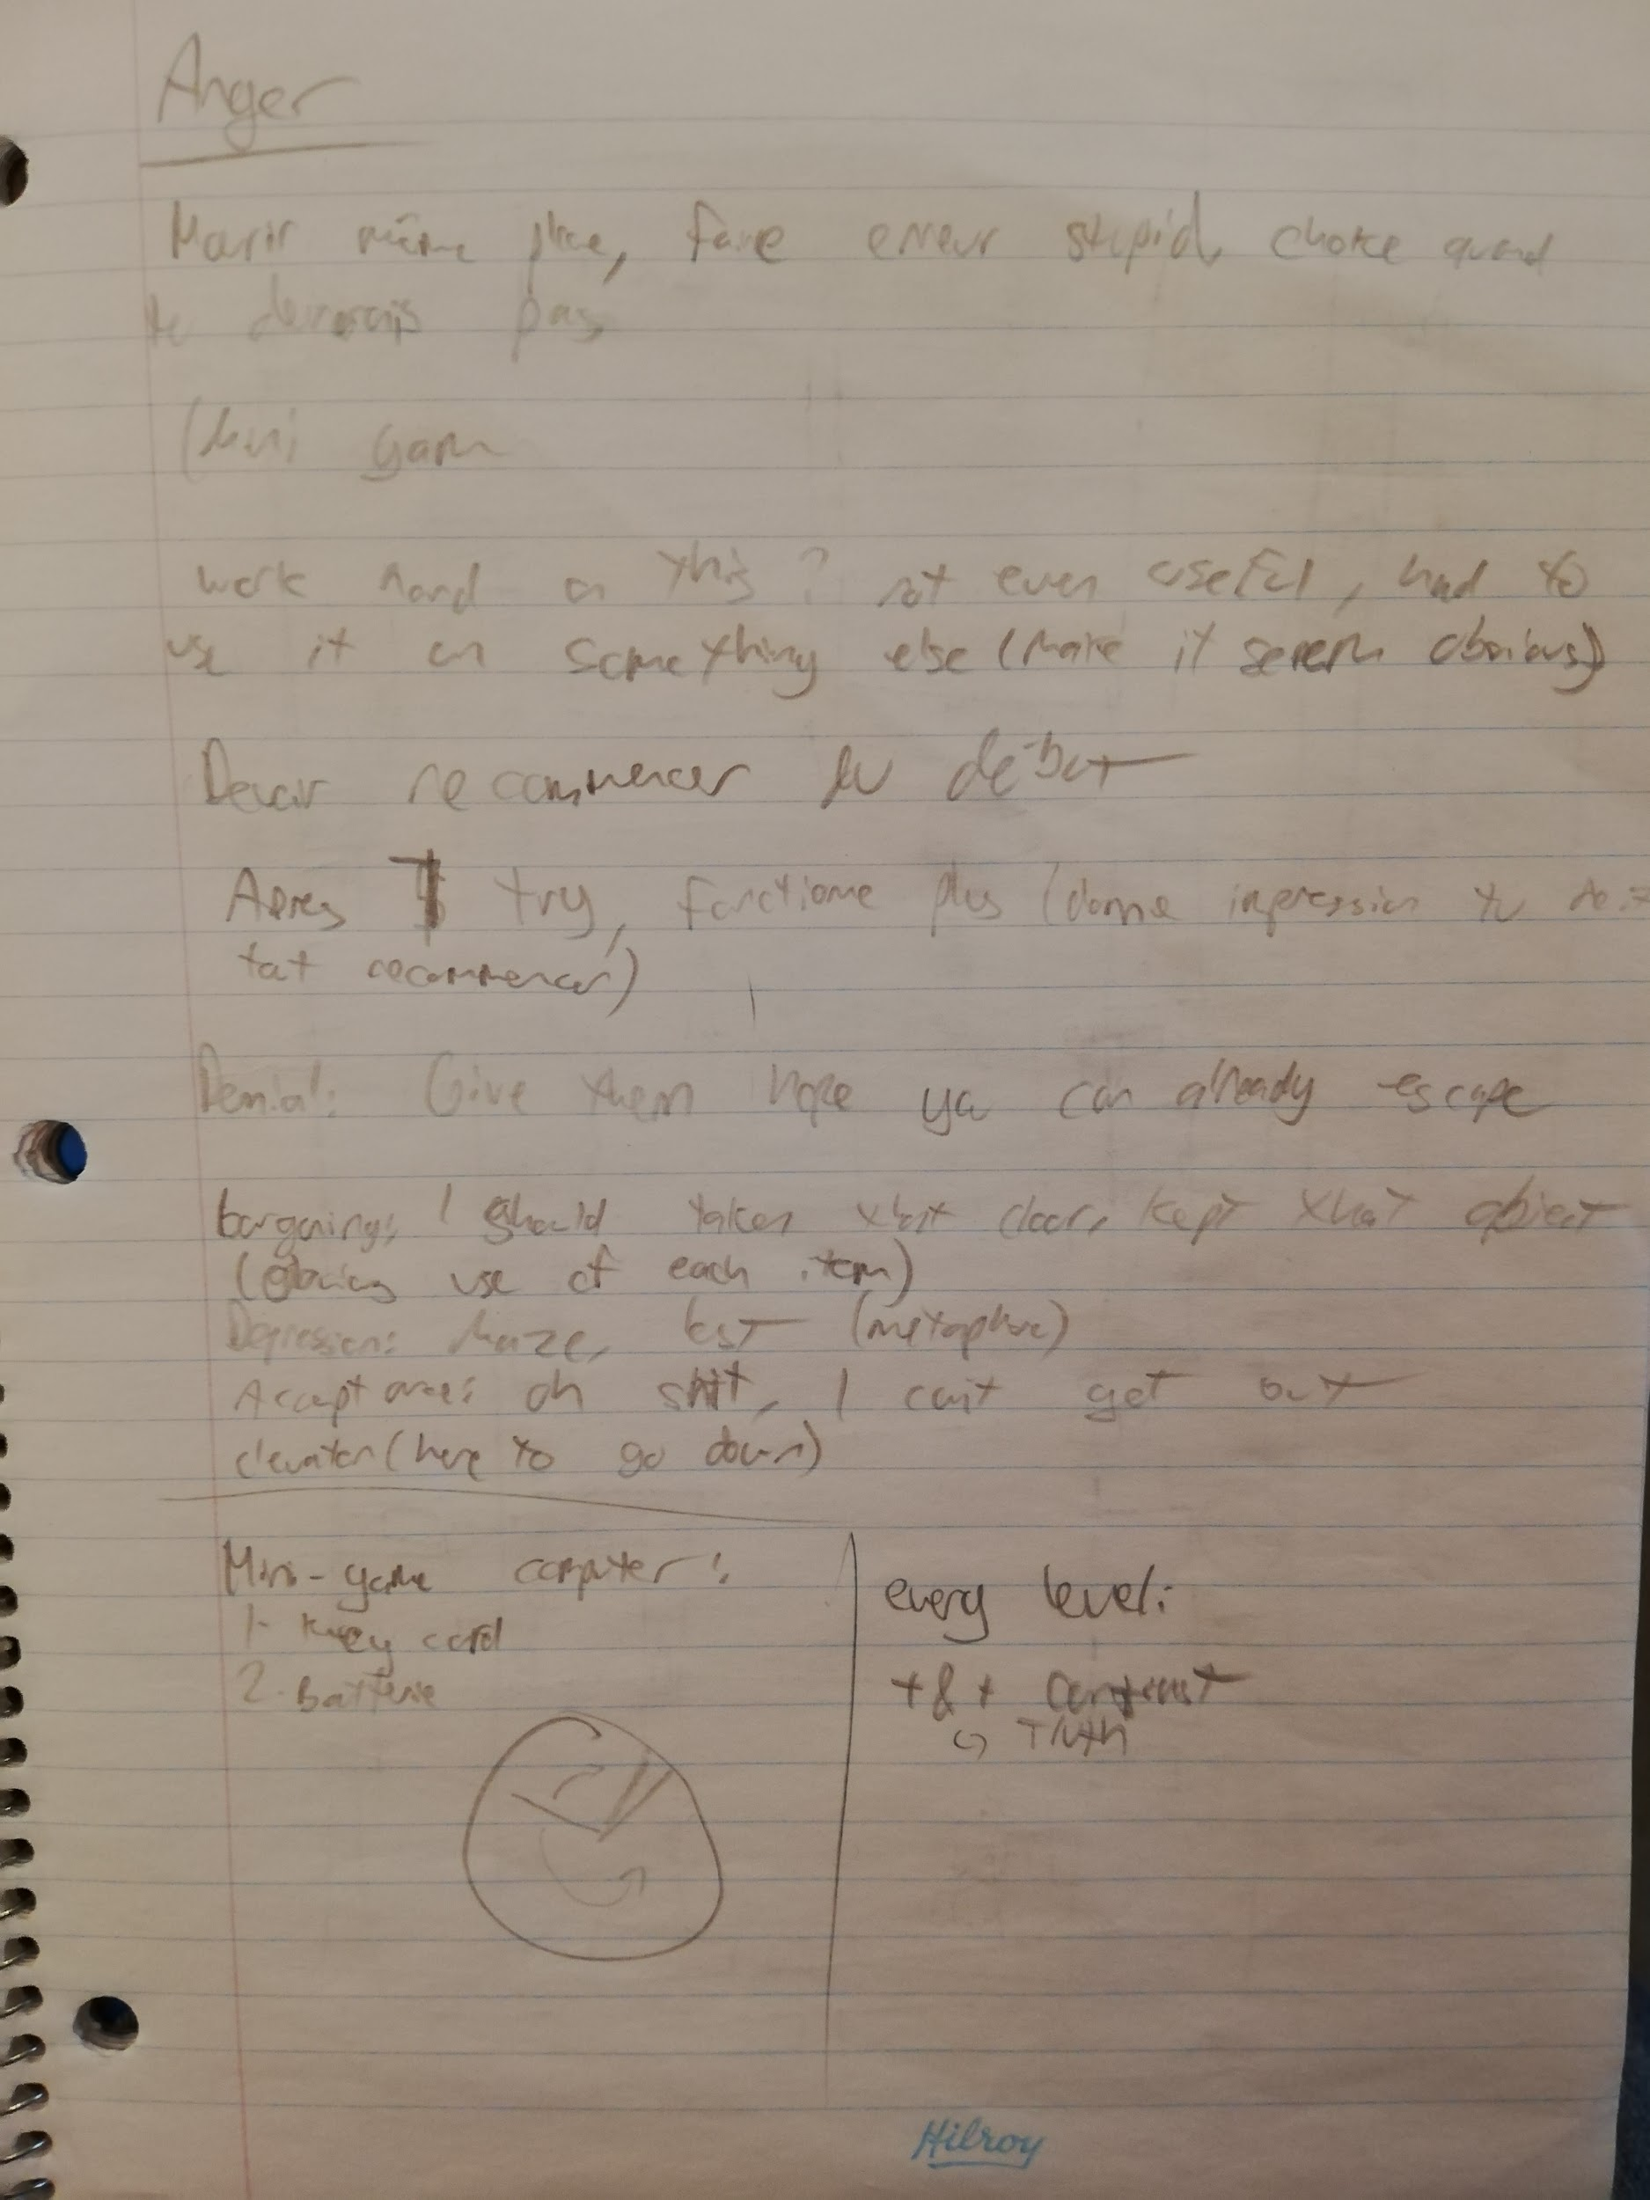

6. The story and the metaphor

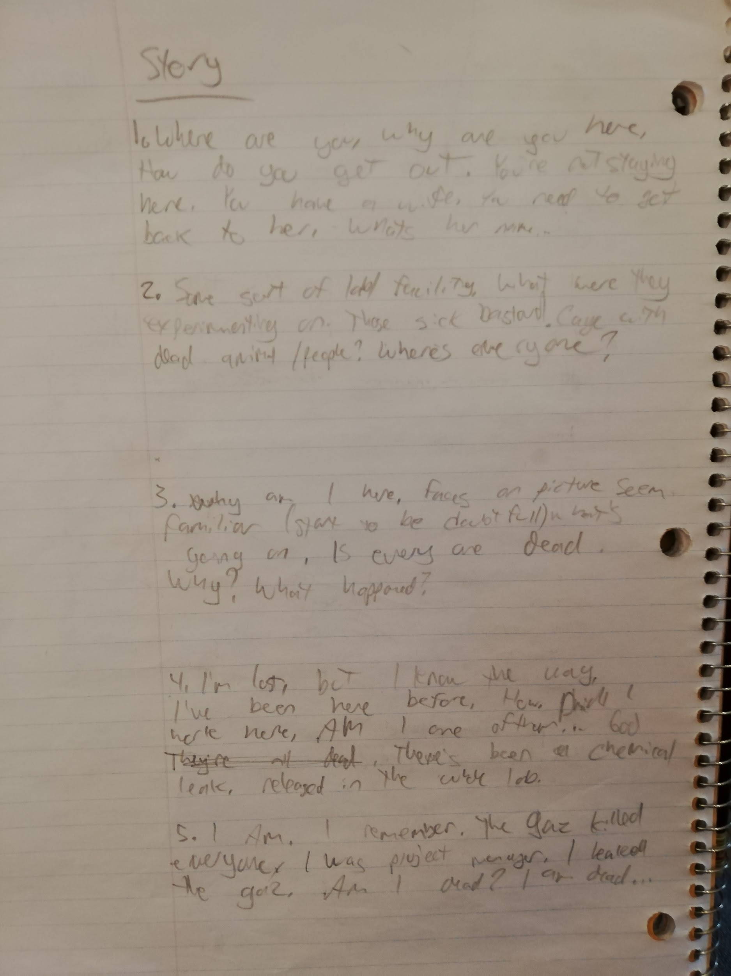

7. Class update 3

<https://docs.google.com/presentation/d/1eJEW25trXlB2fhCCgL6ga5IWuVKbQfyUqnkpqG593Qg/edit>

1. Index 1
2. Class update 2 ; Index 2
3. The puzzles; Index 3
4. The room designs ; Index 4
5. Room themes ; Index 5
6. Story ; Index 6
7.